1. Write a Java program to print the string data in initcap format?

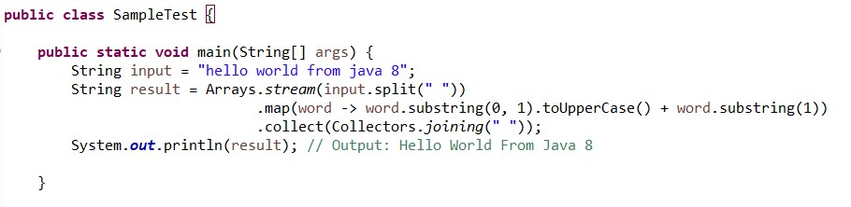

1. How do you find frequency of each character in a string using Java 8 streams?

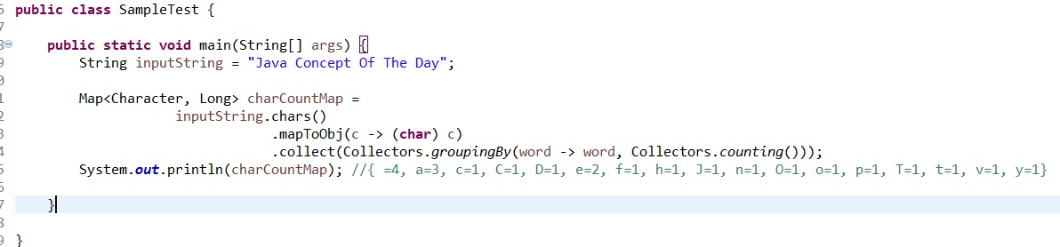

1. How do you find frequency of each element in an array or a list?

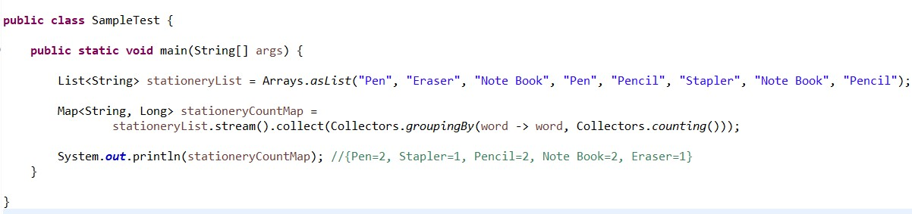

1. How do you sort the given list of decimals in reverse order?

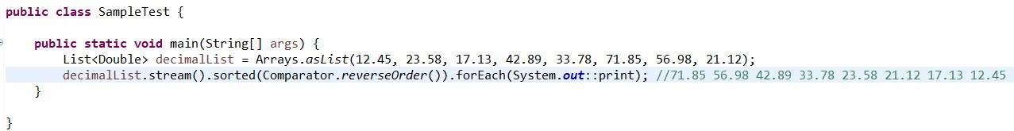

1. From the given list of integers, print the numbers which are multiples of 5?

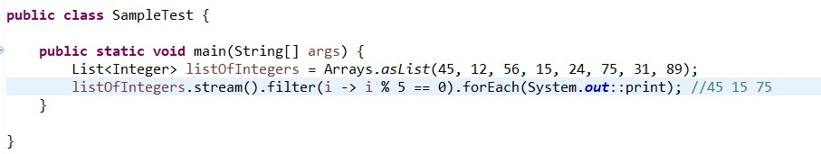

1. Given a list of integers, find maximum and minimum of those numbers?

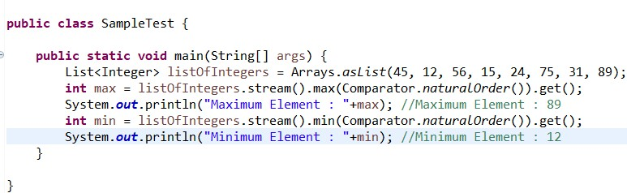

1. How do you merge two unsorted arrays into single sorted array using Java 8 streams?

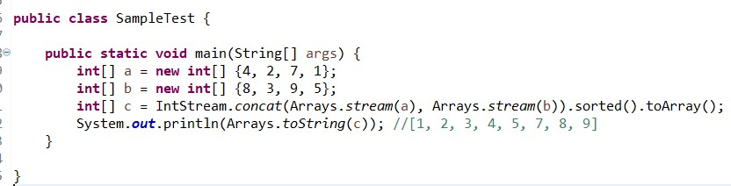

1. How do you merge two unsorted arrays into single sorted array without duplicates?

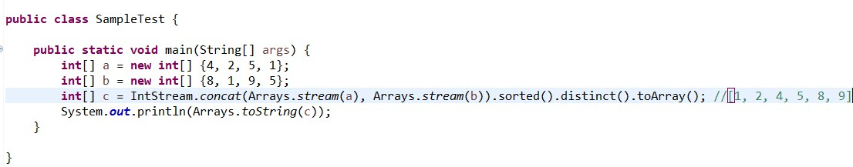

1. How do you get three maximum numbers and three minimum numbers from the given list of integers?

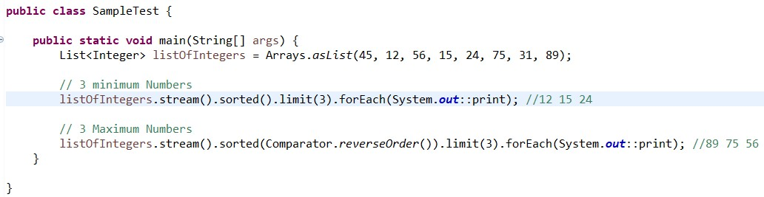

1. Java 8 program to check if two strings are anagrams or not?

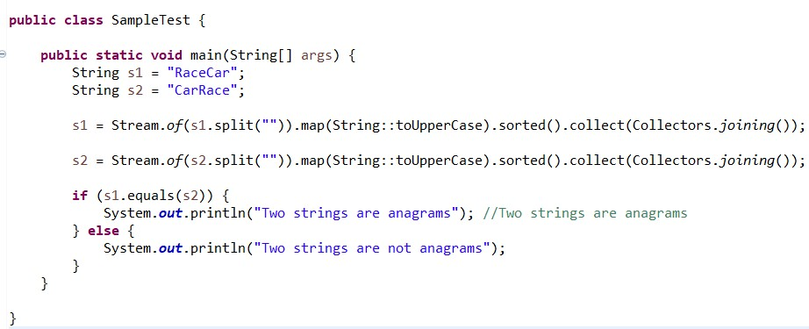

1. Find sum of all digits of a number in Java 8?

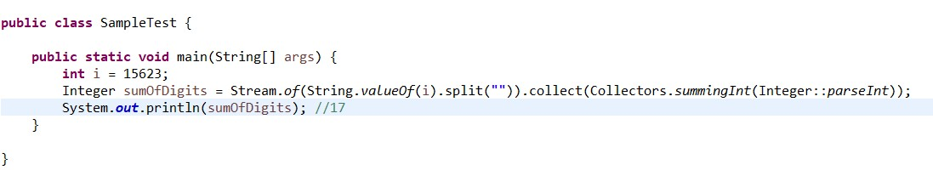

1. Find second largest number in an integer array?

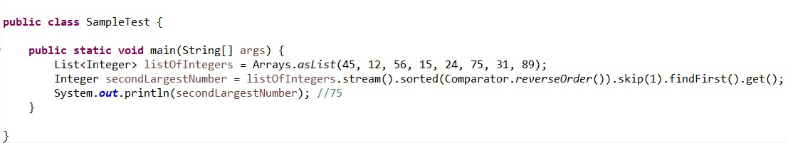

1. Given a list of strings, sort them according to increasing order of their length?

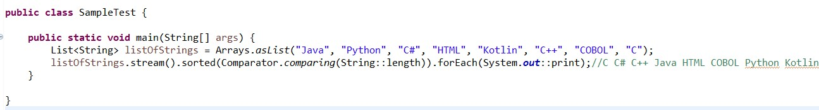

1. Given an integer array, find sum and average of all elements?

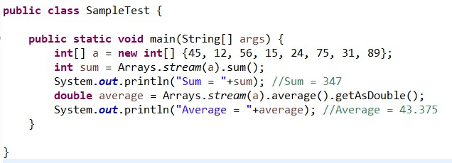

1. How do you find common elements between two arrays?

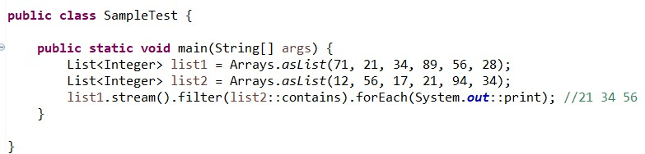

1. Reverse each word of a string using Java 8 streams?

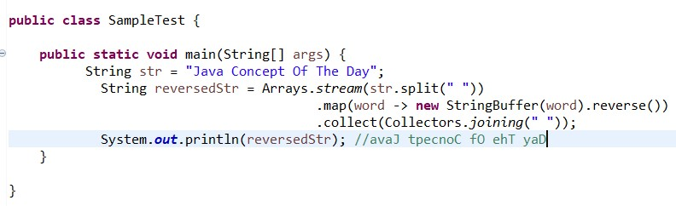

1. Reverse an integer array?

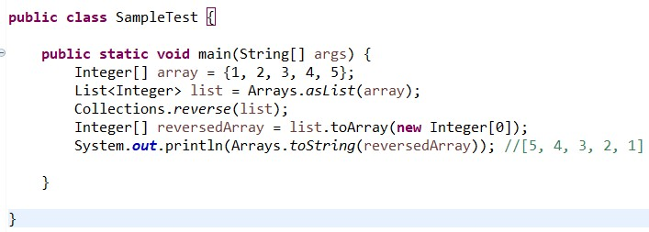

1. How do you find sum of first 10 natural numbers?

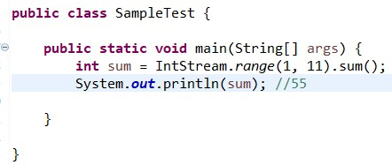

1. Print first 10 even numbers?

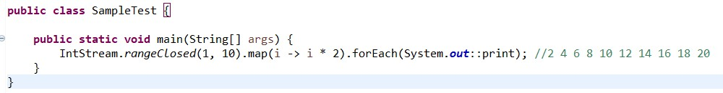

1. How do you find the most repeated element in an array?

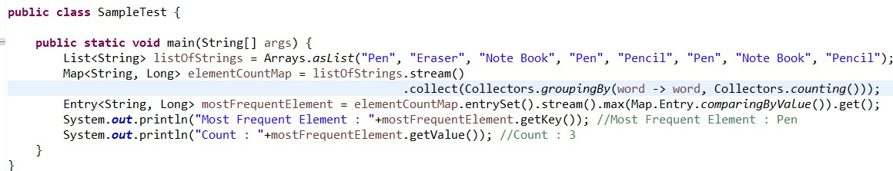

1. Given a list of strings, find out those strings which start with a number?

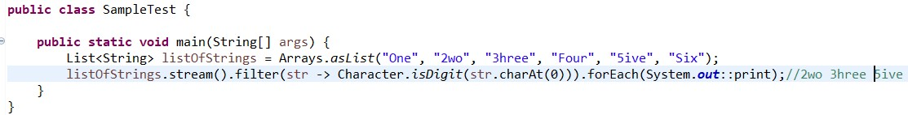

1. How do you extract duplicate elements from an array?

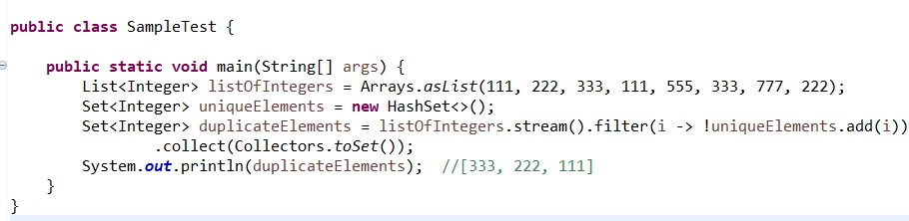

1. Print duplicate characters in a string?

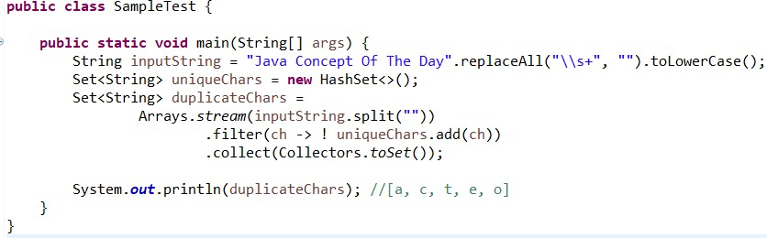

1. Find first repeated character in a string?

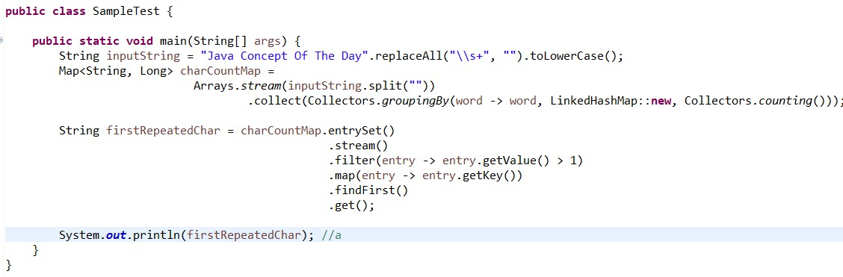

1. Find first non-repeated character in a string?

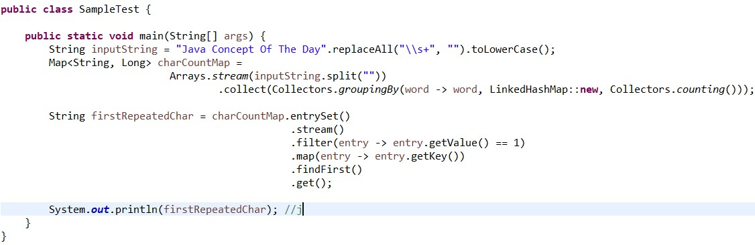

1. How do you get last element of an array?

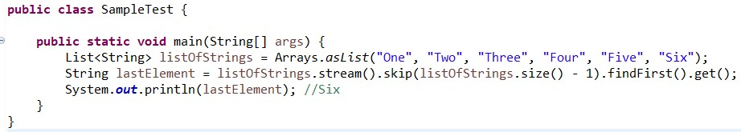

1. Find the age of a person in years if the birthday has given?

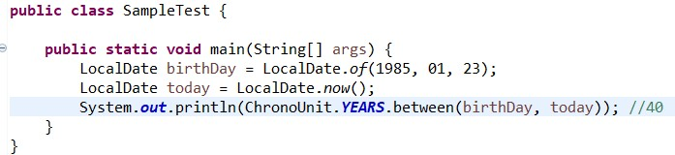

1. Given a list of integers, find out all the numbers starting with 1 using Stream functions?

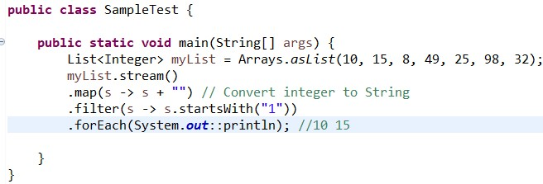

1. How to find duplicate elements in a given integers list in java using Stream functions?

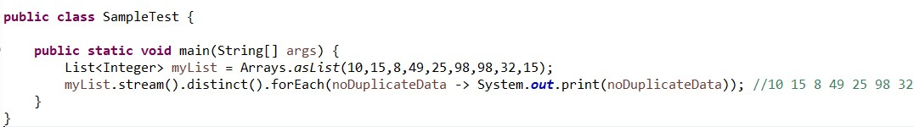

1. Given the list of integers, find the first element of the list using Stream functions?

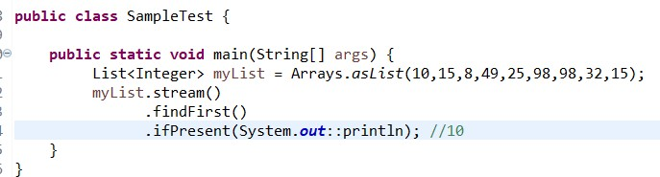

1. Given a list of integers, find the total number of elements present in the list using Stream functions?

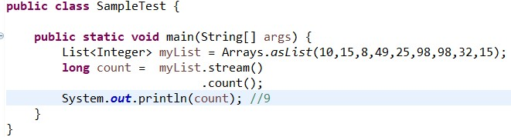

1. Given a list of integers, find the maximum value element present in it using Stream functions?

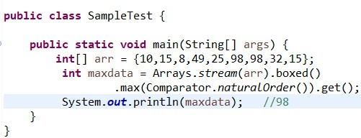

1. Given an integer array nums, return true if any value appears at least twice in the array, and return false if every element is distinct?

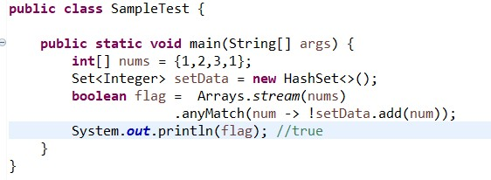

1. Write a Java 8 program to concatenate two Streams?

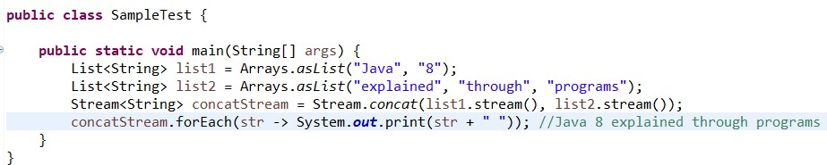

1. How to find only duplicate elements with its count from the String ArrayList in Java8?

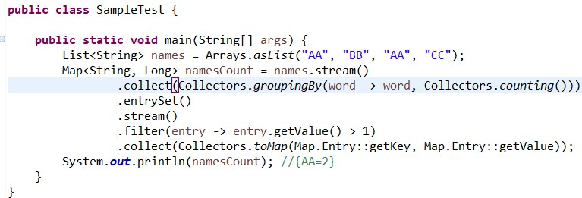

1. In Given string find the max and min length word?

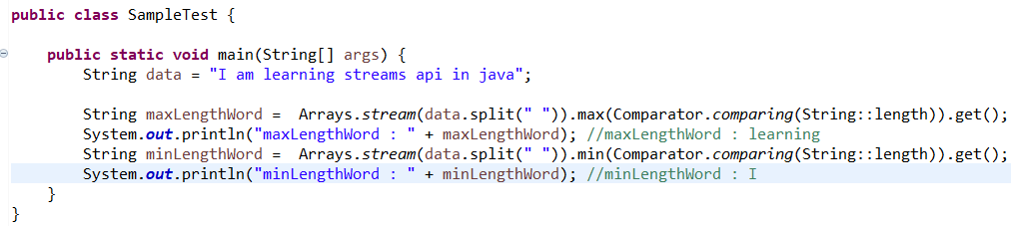

1. Remove duplicates from the string and return in the same order

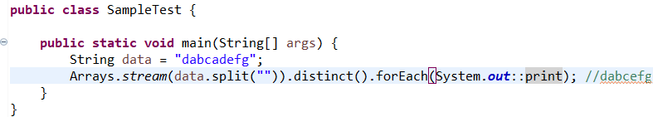

1. Find the word that has the second and third highest length words?

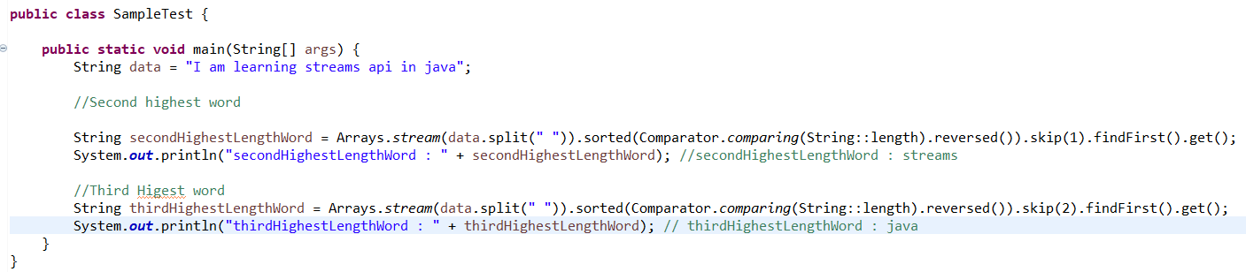

1. Divide given integer list into lists of even and odd numbers?

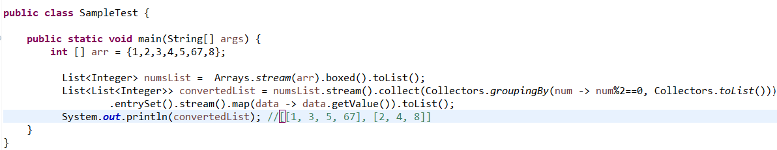

1. Given an array, find the sum of unique elements?

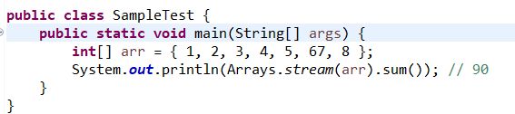

1. Given a string, find the first non-repeated character?

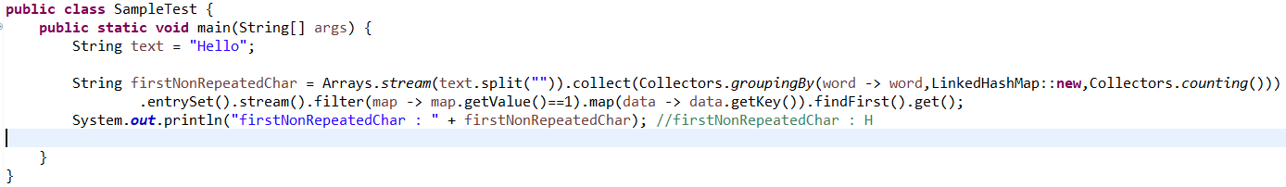

1. Given a string, find the first repeated character?

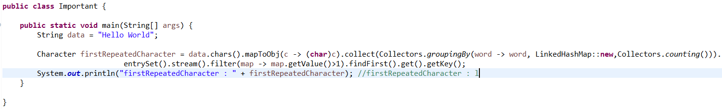

1. Given a list of strings, create a list that contains only integers?

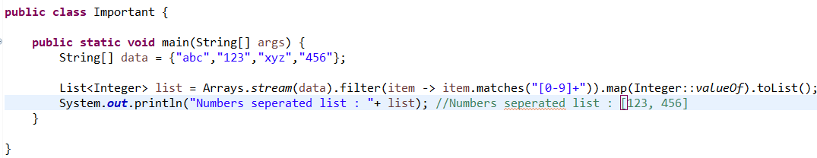

1. Find the products of the first two elements in an array?

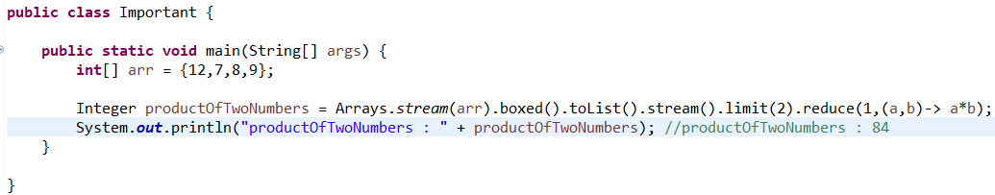

1. Group /Pair anagrams from a list of Strings?

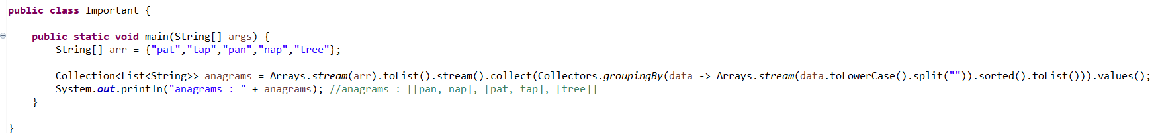

1. Given the string[] group the strings based on the middle character?

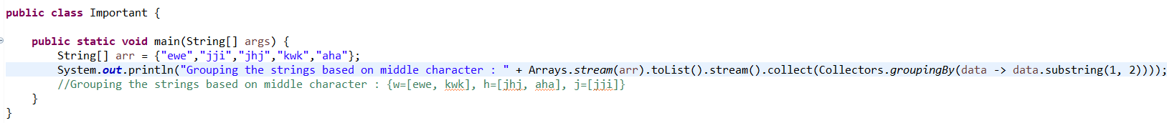

1. Write a program to do the union of two integers arrays?

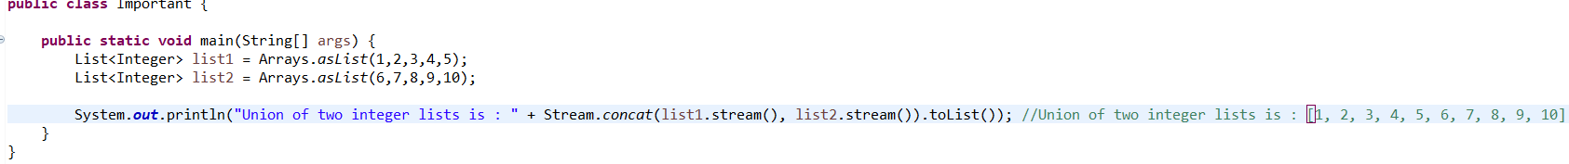

1. Remove all non-numeric characters from a list?

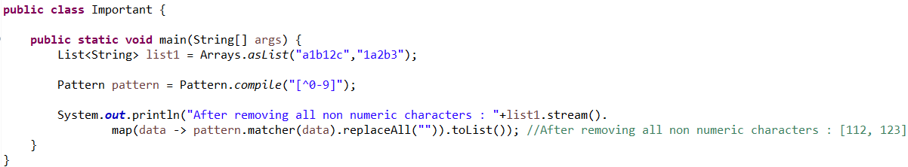

1. Write a program to print only characters?

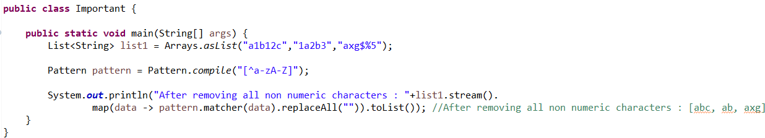

1. Find the intersection of two lists using Java streams

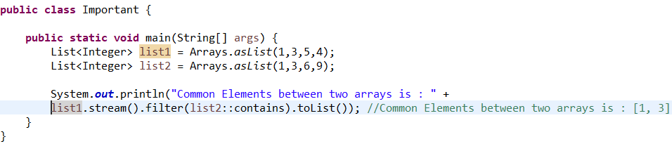

1. Write a program to Multiply array elements

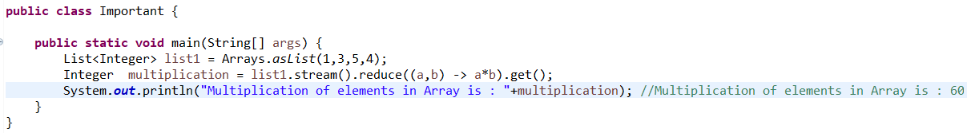

1. Convert a list of string to uppercase and then concatenate

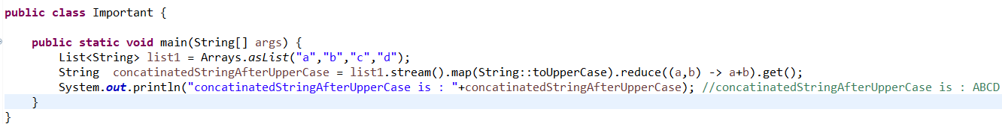

1. Find the average salary from each department

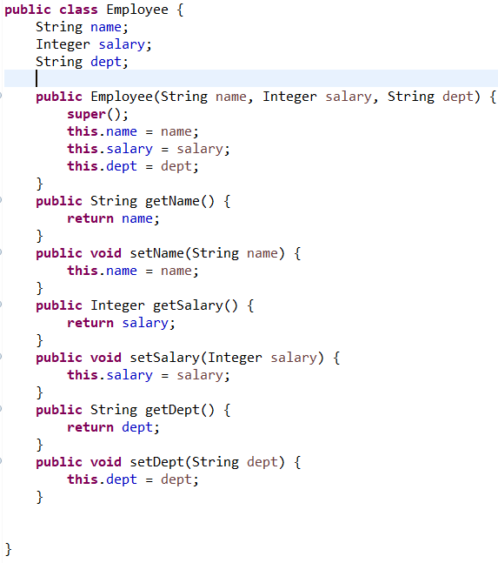

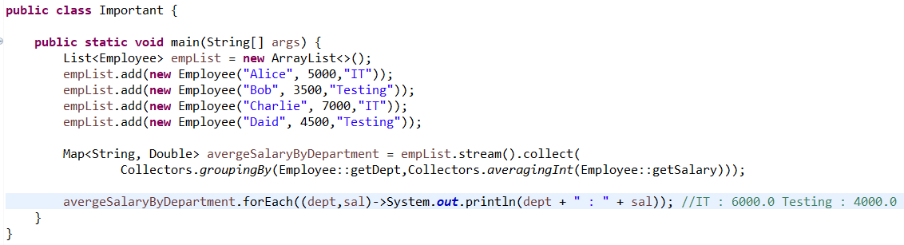

1. Write a program on Group By Functions?

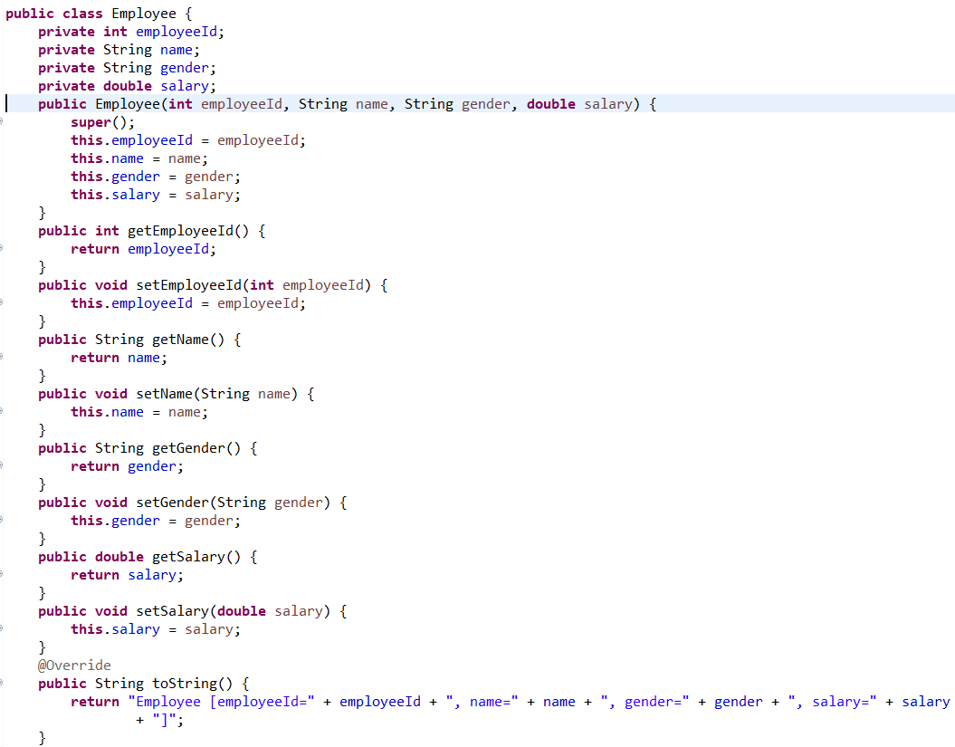

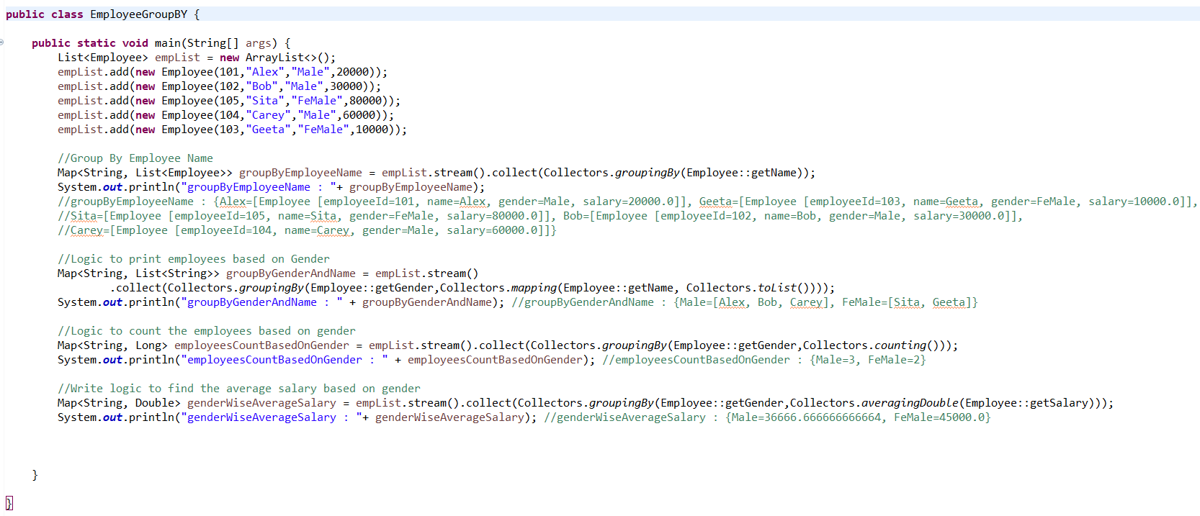

1. Write few programs on Java 8 Streams on Employee Object?



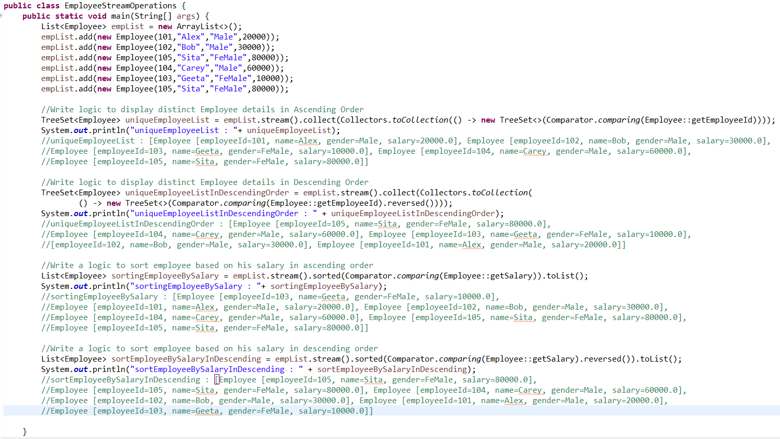

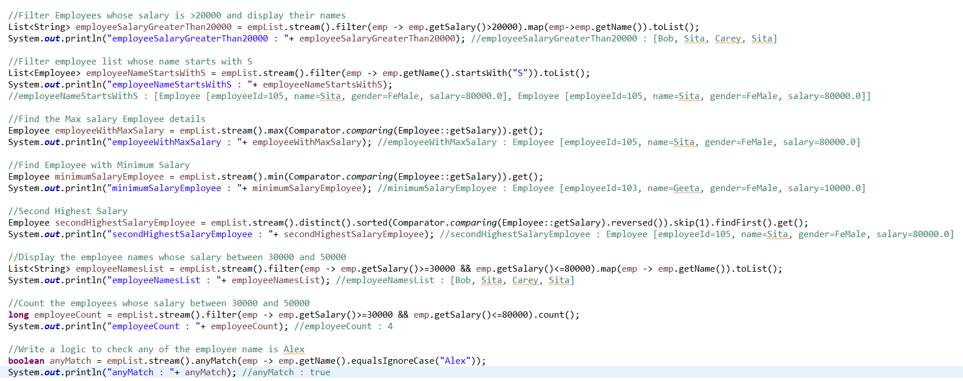

1. Write Java 8 programs to perform possible operation on Strings?

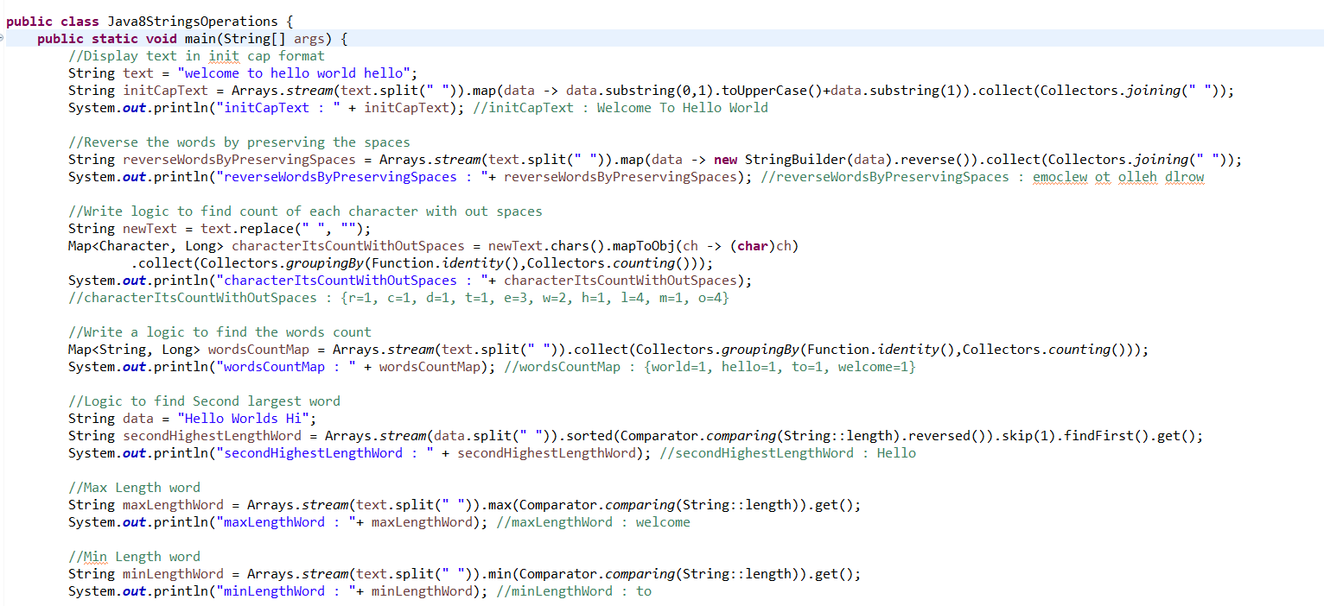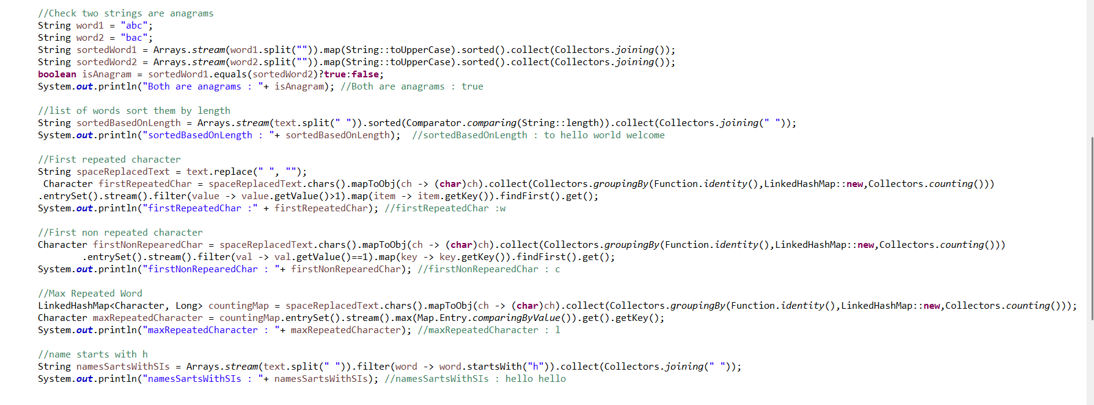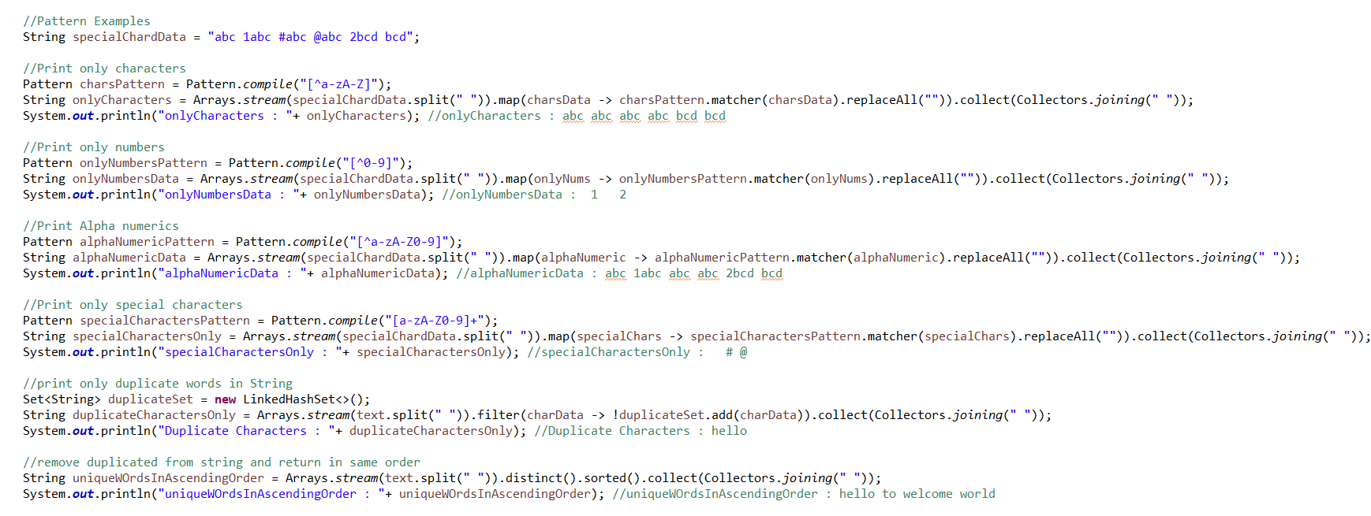

1. Java 8 programs on integers?

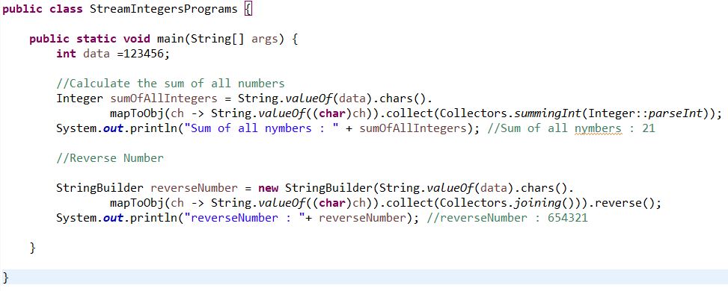

1. Few Java 8 programs on Arrays?

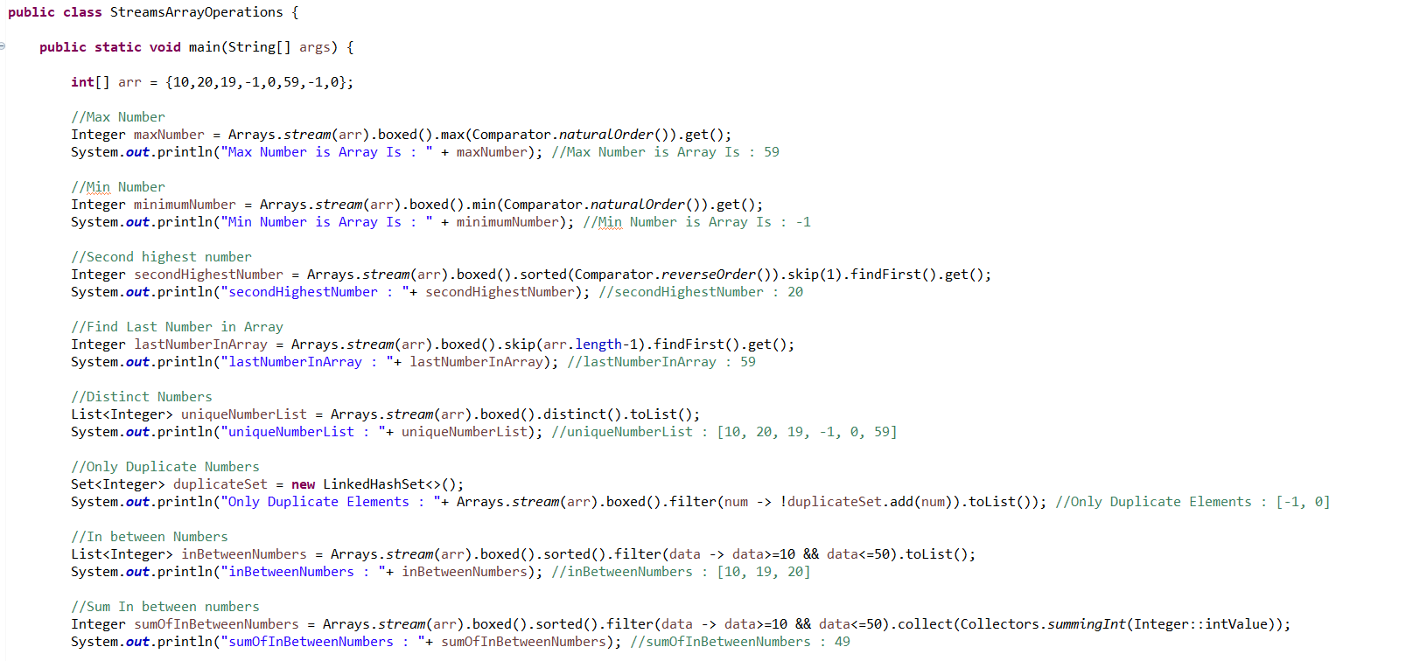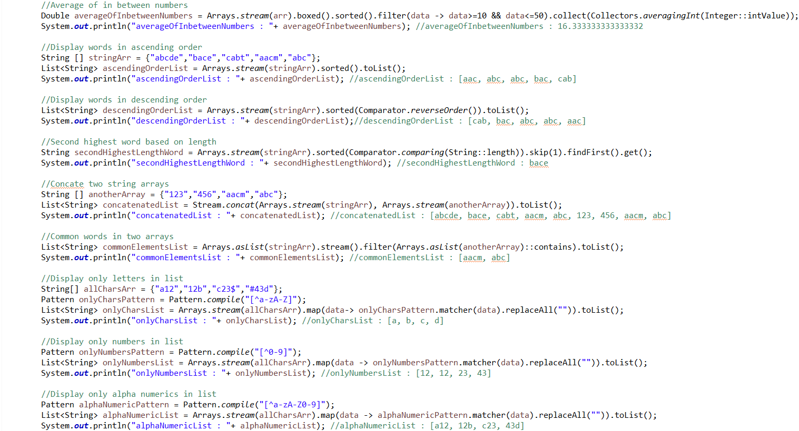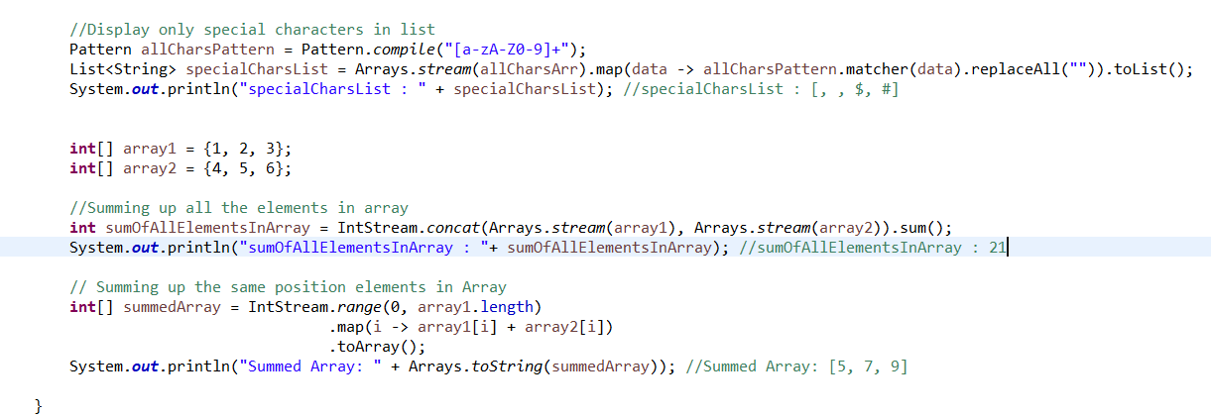

1. Few programs on Java 8 Map?

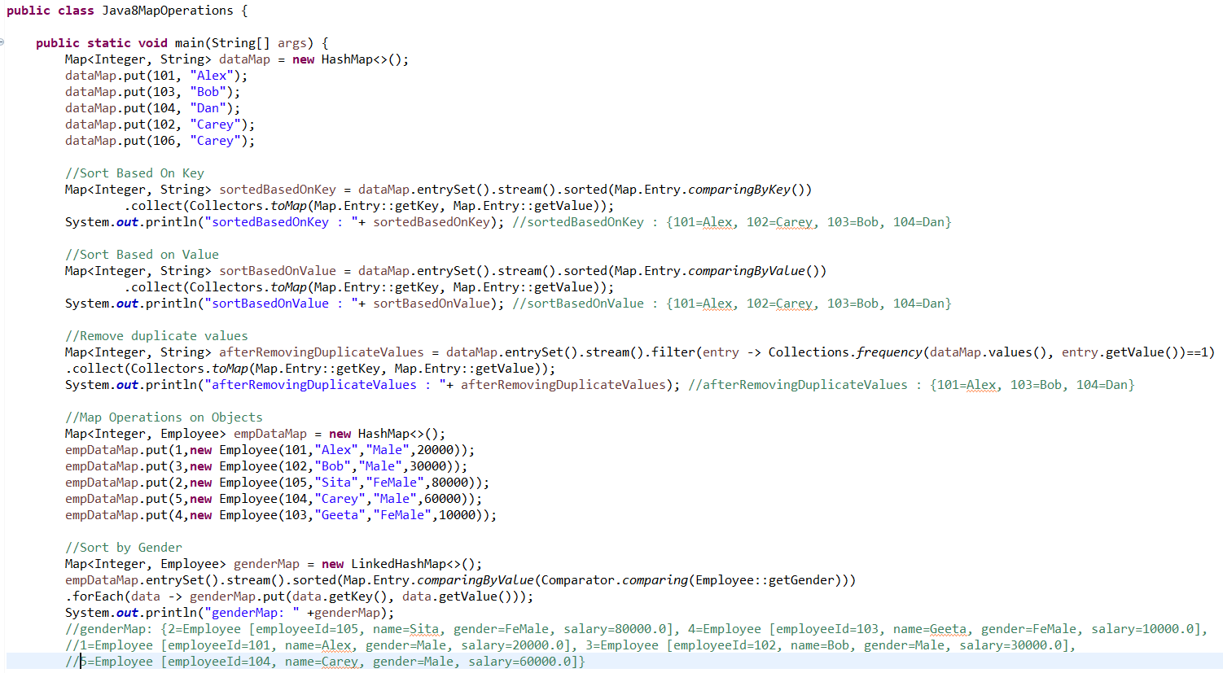

1. Find Missing number in array?

